SUPERVISION
Date / time: 16/10/2025

Main issues discussed
1. Core goals and stretch goals
2. Timeline and assessment arrangements
3. Marking and weighting of the three assignments
4. Process evidence, record-keeping, and conventions for appendices/links
5. Will use each one-to-one meeting to give you technical Q&A training.

Work shown
the presentation by my supervisor, John Halloran
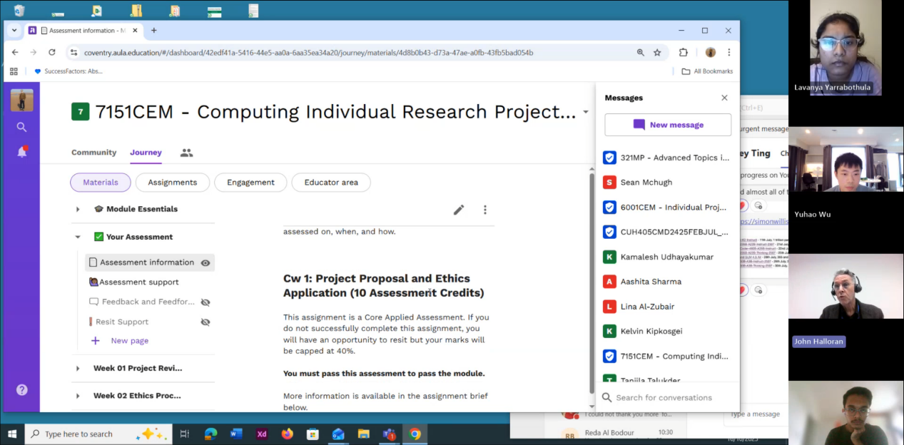

Questions asked; how questions were answered
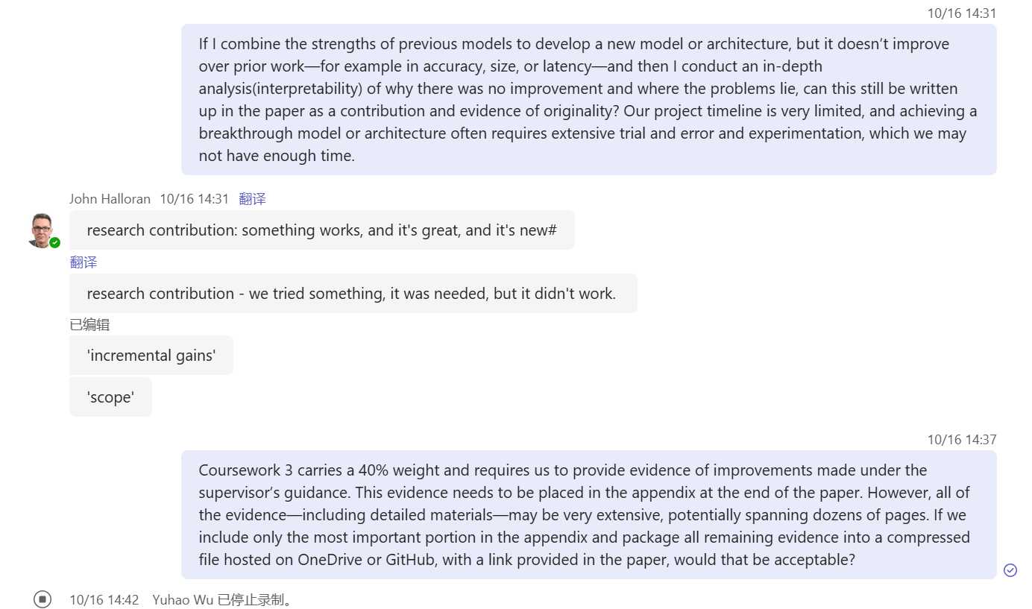
Answer
1. That’s fine. Basically, there are two types of research contributions. The first is: what we did works, it is new, and it is great. This is the ideal kind of contribution. The other is: we tried something that was necessary to try, but it did not succeed.
2. This is absolutely correct; you can do it this way.

Email
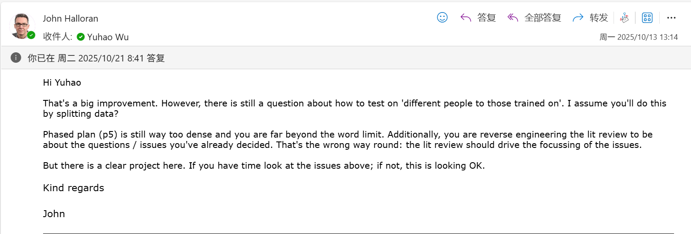

Computing Project
WORK DONE
1. Continue revising the proposal.
2. Train and test the 6 baseline models (knn, random forest, inceptiontime, tst, minirocket and multirocket)on the RealWorld dataset.
3. Start preparing for the preprocessing work on the LARa dataset.

Issues and challenges
- The proposal is still too dense, and its readability is not high enough.
- I’ve used some acceleration methods, but the training speed of MiniRocket and MultiRocket is still very slow.

Actions for next week
1. Complete the preprocessing of the LARa dataset and train and test several baseline models.
2. Prepare for the work of designing a new model.

Evidence
https://livecoventryac-my.sharepoint.com/:v:/g/personal/aa1910_coventry_ac_uk/Ed05xER6ysRDkJnvjXC6q6cBfm4uYf7eGohUF6cy_22sig

https://github.com/laracroft-leo/Computing-project/tree/main/Project%20process/week%205%2010.13-10.19

